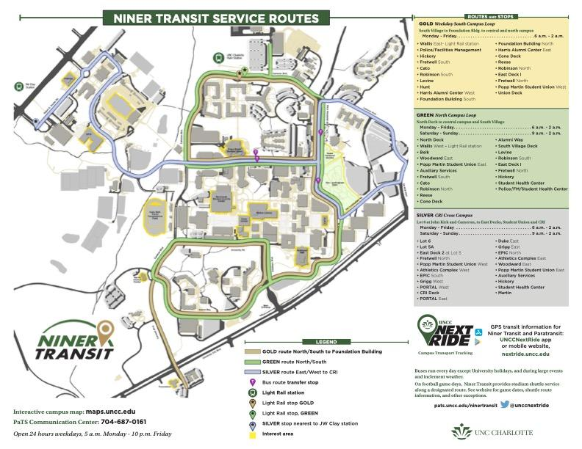

**GOLD(Thien) (use 2020 data only)**

**GREEN (Felipe) (use 2020 data only)**

My data is in the excel file in this folder titled GREEN: <https://drive.google.com/drive/folders/12zqkxZb8KuVD-tO7SSfTHuxDza5LAj_o?usp=sharing>

**SILVER(Jaren) (use 2020 data only)**